PRACTICAL TASK: L9 — Identify Intent for 10 Niche Keywords1. Choose your niche — the industry or topic you want to build a website or career around (e.g., personal finance, cooking, travel in India, digital marketing, fitness, real estate).
2. Think of 10 keywords your target audience might search. Write them down WITHOUT using any tool yet — just brainstorm from your own knowledge.
3. For each keyword, classify: (a) Short-tail or Long-tail? (b) Search Intent: Informational, Navigational, Transactional, or Commercial? (c) What content format should you create for this keyword?
4. Now Google each keyword in Incognito mode. Look at the top 3 results. Does Google show: blog posts, product pages, videos, or local results? Does this match the intent you identified?
5. Identify 3 keywords where your intent classification was WRONG based on what Google actually shows. This is a key SEO learning.
6. Find 2 LSI keywords for each of your 10 keywords using Google's 'Related Searches' at the bottom of results.
7. Submit: A table with 10 keywords, intent classification, content format suggestion, and 2 LSI keywords each.

ANSWER:-
- My niche is Fashion Designing.
- And 3.
KEYWORDS | Short or long | Intent | Content format
(a) fashion designing course in India | Long-tail | Informational | Course page
(b) how to become fashion designer | Long-tail | Informational | Informative blog
(c) best fashion designing colleges in India | Long-tail | Commercial | Comparison
(d) types of fabrics for clothing design | Long-tail | Informational | Informative blog
(e) fashion sketching ideas for beginners | Long-tail | Informational | Photos/  images
(f) latest frock design patterns | Long-tail | Informational | Patterns information
(g) fashion designers | Short tail | Commercial | Artists profile
(h) latest design patterns | Long-tail | Informational | Information about fashion
(i) latest patterns | Short tail | Informational | Information about fashion
(j) affordable fashion brands India | Long-tail | Commercial | Brand list

4 & 5:-
Google Incognito mode did not show blog posts, product pages, videos, or local results and, my intent (g) turned out to be wrong it is Informational and I mistakenly wrote Commercial because I thought it was about promotions or popularity.
6.
(a) Fashion designing course in India
=diploma in fashion designing
=fashion design course fees in India
(b) How to become fashion designer
=steps to become fashion designer after 12th
=skills required for fashion designing career
(c) Best fashion designing colleges in India
=NIFT/NID colleges in India list
=top private fashion design institutes India
(d) Types of fabrics for clothing design
=natural vs synthetic fabrics list
=places to purchase premium fabrics
(e) Fashion sketching ideas for beginners
=basic fashion croquis/sketches drawing tutorial
=easy dress design sketches step by step
(f) Latest frock design patterns
= travel friendly frock designs for girls
=trendy long frock design ideas
(g) Fashion designers
=famous Indian fashion designers list
=top international fashion designers’ biography
(h) Latest design patterns
=modern dress design trends 2026
=traditional wear pattern styles latest
(i) Latest patterns
=clothing pattern trends for women 2026
=fashion print and design trends

(j) Affordable fashion brands India
=budget clothing brands online India
=cheap stylish dresses Indian brands

PRACTICAL TASK: L10 — Search 5 Keywords on Google Keyword Planner8. Go to ads.google.com and create a free Google Ads account (you don't need to run any ads).
9. Open Keyword Planner > Discover New Keywords.
10. Set Location: India. Language: English.
11. Search for 5 keywords related to your chosen niche from L9.
12. For each keyword note: (a) Average Monthly Searches, (b) Competition level, (c) Top of Page Bid (Low and High), (d) 3-month trend (up, down, stable).
13. From each keyword's results, pick the 3 best long-tail variations (look for low competition + decent search volume).
14. Now open Ubersuggest (app.neilpatel.com). Search the same 5 keywords. Compare: Does Ubersuggest show different search volumes than GKP? Note the SD (SEO Difficulty) score for each.
15.Open AnswerThePublic.com, select India + English, search your primary niche keyword. Screenshot the question wheel and note 10 questions you could write blog posts about.
16. Submit: A completed spreadsheet/table with all data collected from GKP + Ubersuggest + 10 questions from AnswerThePublic.

ANSWER:-
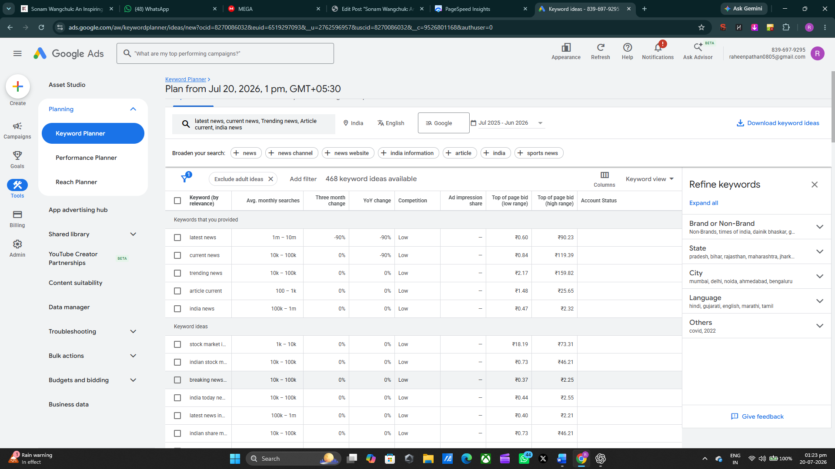
Google keyword planner.
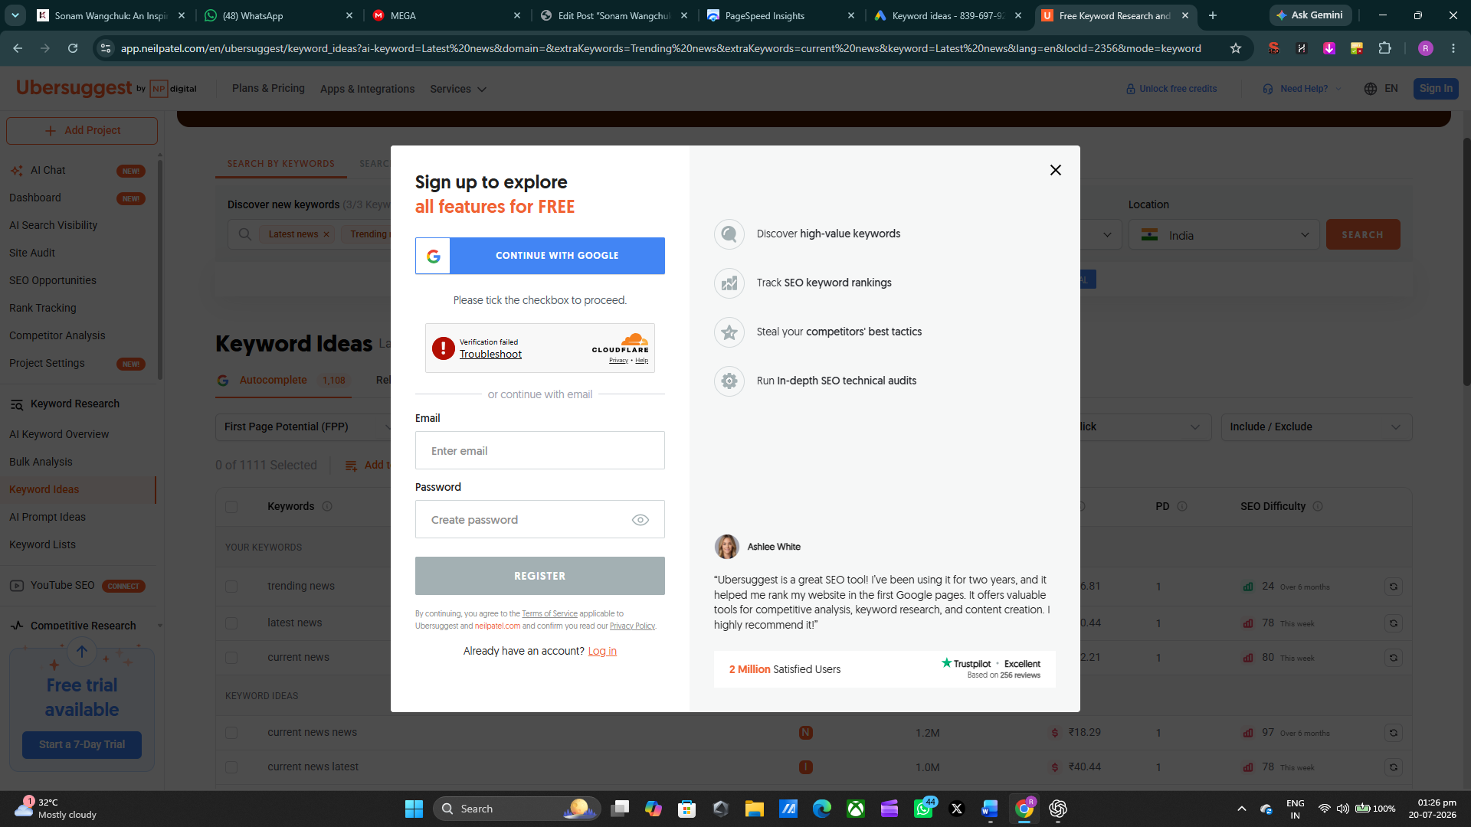
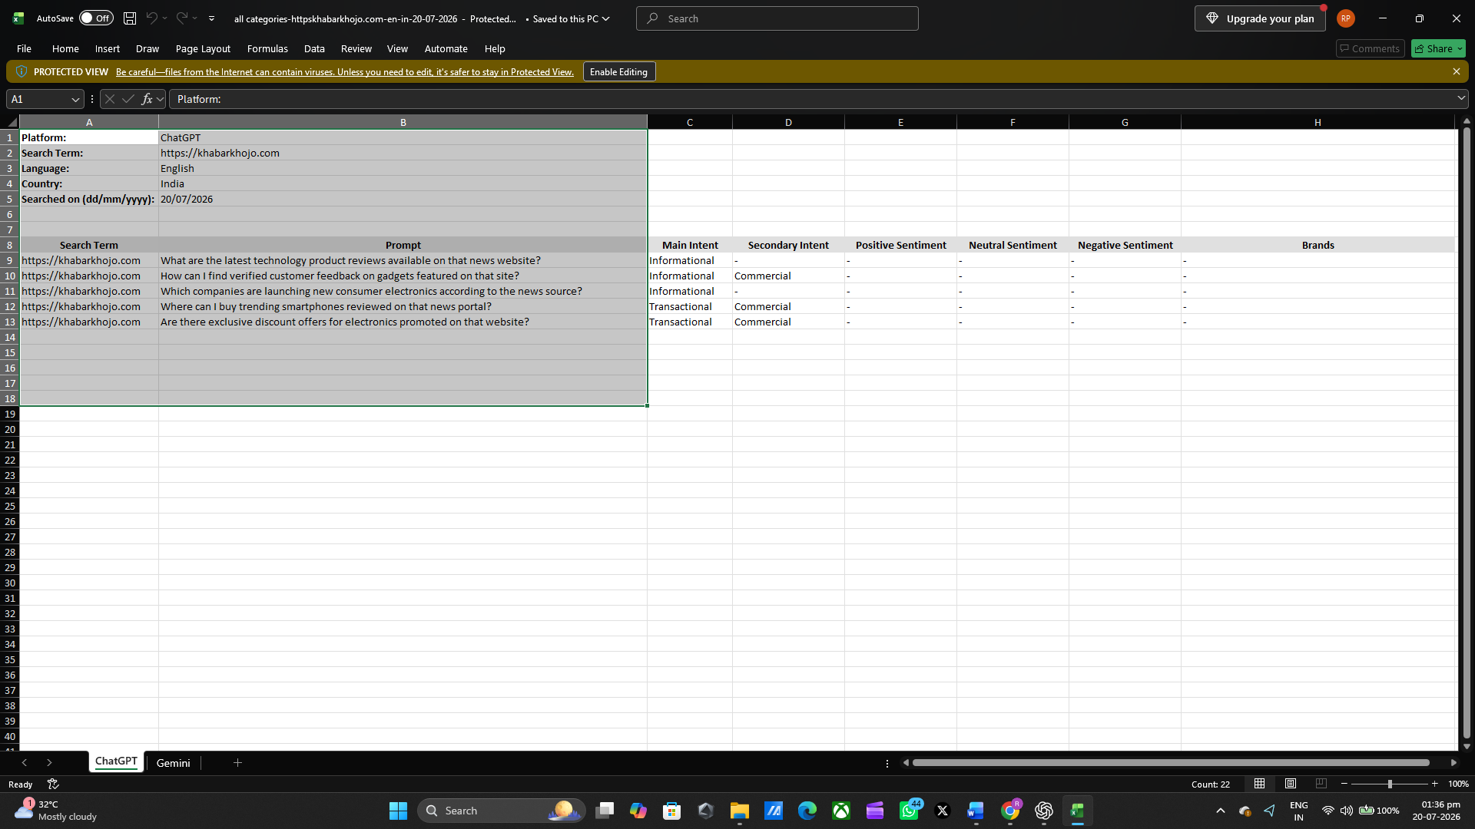

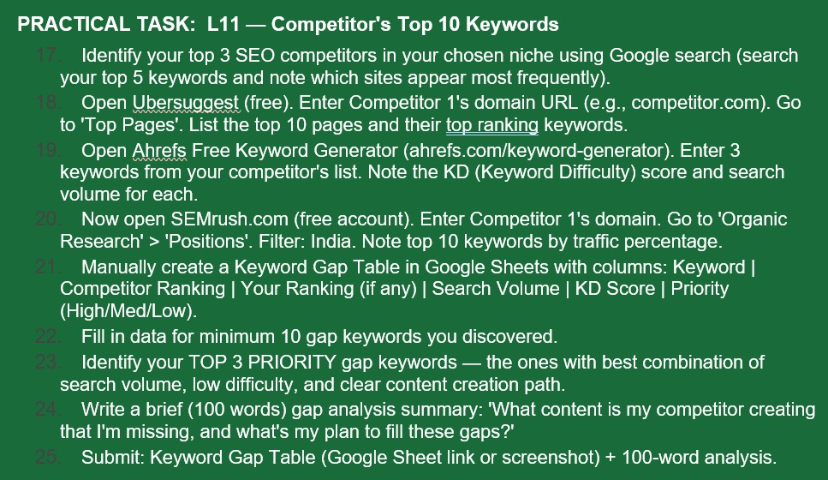

ANSWER:-
17. Top 3 SEO Competitors
No. | SEO Competitor | Domain | Main Content Areas
1 | The Indian Express | indianexpress.com | India, World, Politics, Business, Sports, Technology
2 | Hindustan Times | hindustantimes.com | India, World, Business, Technology, Sports, Entertainment
3 | NDTV | ndtv.com | India, World, Business, Sports, Entertainment, Technology

18.
No. | Keyword | Competitor
1 | live score | The Indian Express
2 | live cricket score | The Indian Express
3 | indian express | The Indian Express
4 | cricket live score | The Indian Express
5 | today IPL match | The Indian Express
6 | India news | The Indian Express
7 | breaking news India | The Indian Express
8 | latest news today | The Indian Express
9 | world news | The Indian Express
10 | business news | The Indian Express
19.
Ahrefs research format
Keyword | Search Volume | KD | Why selected
India news | High | High | Core Khabar Khojo category
breaking news India | High | High | Directly matches site's positioning
Ahmedabad news | Medium | Medium | Local/Gujarat opportunity
20. SEMrush — Competitor 1
For:
Domain: indianexpress.com
Database: India
Section: Organic Research → Positions
Current Semrush data provides these examples:
Keyword | Position | Volume | Traffic %
live score | 3 | 13.6M | 4.05%
live cricket score | 7 | 13.6M | 1.35%
indian express | 1 | 450K | 1.19%
cricket live score | 6 | 5M | 0.66%
Pakistan national cricket team vs England cricket team match scorecard | 4 | 2.24M | 0.37%

21–22. Keyword Gap Table
Here is the Khabar Khojo-focused gap table you can put into Google Sheets.
Your Ranking = N/A means Khabar Khojo currently has no publicly verifiable ranking for that keyword in the sources I could check. I am not inventing a ranking.
Keyword | Competitor Ranking | Your Ranking | Search Volume | KD | Priority
India news | Indian Express / HT / NDTV | N/A | High | High | Medium
breaking news India | Indian Express / HT / NDTV | N/A | High | High | Medium
latest India news | HT / NDTV | N/A | High | High | Medium
Ahmedabad news | TOI / local news competitors | N/A | Medium | Medium | High
Gujarat news | Major news portals | N/A | Medium | Medium | High
Ahmedabad weather | Weather/news portals | N/A | Medium | Medium | High
India weather news | News/weather portals | N/A | Medium | Medium | High
business news India | HT / NDTV / major business portals | N/A | High | High | Medium
stock market news India | Financial/news portals | N/A | High | High | Medium
world news today | NDTV / HT / Indian Express | N/A | High | High | Low
Why these are "gap keywords"
Khabar Khojo already has content around Ahmedabad, Gujarat, weather, India News, Global News and business-related stories, but it does not yet have the scale of dedicated keyword coverage that the large news competitors have. The current Khabar Khojo homepage shows India News, Weather, Weather News, Government, Politics, Worldwide News and Global News categories.
23. TOP 3 Priority Gap Keywords
For the assignment, select:
1. Ahmedabad news
Reason: Khabar Khojo already publishes Ahmedabad-focused stories such as the Silver Oak incident, Asarva water-tank incident and Ahmedabad railway redevelopment.
2. Gujarat news
Reason: Gujarat is a natural geographic content area for Khabar Khojo, allowing the site to build multiple related articles rather than targeting only one story.
3. Ahmedabad weather
Reason: Khabar Khojo already publishes weather-related content, including Ahmedabad rain alerts and Statue of Unity weather coverage.
These three also provide a clear content creation path: local news + Gujarat updates + weather.

24. 100-Word Gap Analysis
Gap Analysis
Khabar Khojo currently covers India, world, weather, government, politics and local Ahmedabad stories, but larger competitors such as Indian Express, Hindustan Times and NDTV have much broader keyword coverage and stronger rankings across high-volume news searches. The main opportunity for Khabar Khojo is to build topical authority through focused local and regional content. The first priority will be Ahmedabad news, Gujarat news and Ahmedabad weather, supported by regular original articles, internal linking and properly optimized titles, URLs and images. After establishing these topics, Khabar Khojo can gradually target broader India, business, world and breaking-news keywords.

25- N/A

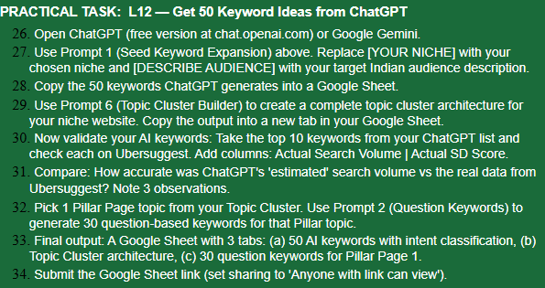
ANSWER:-
33. https://docs.google.com/spreadsheets/d/1ek8o-dFF5E455g39NsEPXCkGxz9UVupOh45uW9l2lG4/edit?usp=sharing

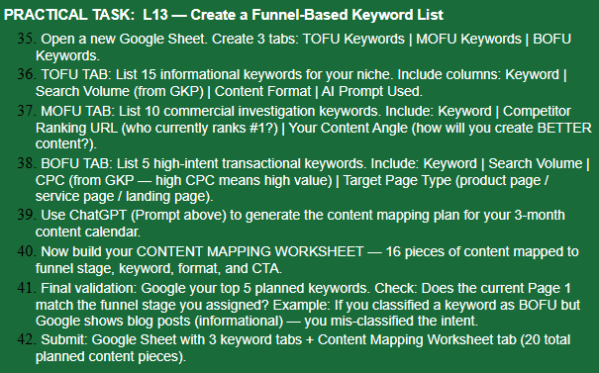
42. https://docs.google.com/spreadsheets/d/1snrSXjSvVkEEQ4f4gL18iBcpUHmelxpOcqE-RTR6A2o/edit?usp=sharing

